Abstract
The dairy sector is a crucial component of human nutrition, yet concerns about milk adulteration and purity have emerged as significant challenges. This paper examines the relationship between purity assurance mechanisms and consumer trust in the dairy sector. Using a mixed-methods approach, survey data from 250 respondents and interviews with industry stakeholders were analyzed. Results suggest that while consumers place strong emphasis on purity certification, trust varies depending on awareness levels and prior experiences. The study concludes that transparent quality practices, stricter regulatory enforcement, and consumer education are essential to strengthen confidence in dairy products.

Introduction
Milk is one of the most consumed and nutritionally important commodities worldwide. However, issues of adulteration, contamination, and compromised quality threaten both consumer health and trust. In India and other developing economies, cases of urea, detergent, and starch adulteration have repeatedly surfaced, raising doubts about dairy safety. Purity assurance, therefore, plays a critical role in shaping consumer perceptions.
This study titled CleanMilk investigates how purity assurance strategies influence consumer trust in the dairy sector. It seeks to answer:
- What purity assurance mechanisms are currently adopted by the industry?
- How aware are consumers of these mechanisms?
- To what extent does purity assurance influence consumer trust and purchase decisions?

Objectives:

To examine the impact of purity assurance mechanisms—such as certifications, testing, and traceability—on consumer trust in food startups.

To evaluate CleanMilk’s business model as an example of trust-driven differentiation within the dairy sector.

To explore management strategies that address challenges of credibility, regulatory compliance, and scalability in trust-based food startups.

To propose a sustainable framework for enhancing consumer trust through purity assurance in emerging dairy ventures.

Literature Survey:
“CleanMilk – Building Consumer Trust through Purity Assurance”

Pure and Modern Milk: An Environmental History Since 1900
https://books.google.co.in/books?hl=en&lr=&id=tQODDQAAQBAJ&oi=fnd&pg=PP1&dq=CleanMilk:+Building+Consumer+Trust+through+Purity+Assurance+give+me+articles+&ots=7mYRD8PAmX&sig=g_TQyLtO_E1d5WhTXneLoWO7wOA&redir_esc=y#v=onepage&q&f=false
Milk has always been seen as a symbol of purity and health, but its journey from farm to table has changed a lot since 1900. The book Pure and Modern Milk by Kendra Smith-Howard explains how ideas of “pure milk” shaped farming methods, public health rules, and even kitchen habits in the twentieth century. Other works, like Melanie DuPuis’ Nature’s Perfect Food, show how governments, doctors, and advertisers convinced people that milk was essential for strong families. Deborah Valenze and Andrea Wiley add a wider view, looking at milk as both a cultural food and a global product. Together, these studies explain why pasteurization, testing, and packaging became so important for safety and trust. They also show how technology such as refrigeration and homogenization made milk safer but also tied dairy more closely to large industries. At the same time, historians of agriculture point out that modern dairy farming created new environmental challenges, like water pollution, waste, and heavy use of antibiotics. From health campaigns to cold-chain transport, the history of milk shows how consumer trust was built through science, regulation, and branding. Understanding this history helps us see both the benefits and trade-offs of “pure and modern” milk.
Milk and Milk Product Safety and Quality Assurance for Achieving Better Public Health Outcomes

Authors: Lopamudra Haldar, H. V. Raghu

https://link.springer.com/chapter/10.1007/978-3-030-93258-9_13

Milk and milk products are important foods because they provide calcium, protein, and vitamins, but they can also carry risks if not handled properly. The idea of milk safety and quality assurance is to make sure that the milk we drink is clean, safe, and healthy. Researchers explain that safety starts at the farm, with healthy cows, clean equipment, and hygienic handling. Pasteurization and boiling are key steps because they kill harmful bacteria like E. coli or Salmonella. Quality assurance also means regular testing for purity, fat content, and absence of harmful chemicals or adulteration. Studies highlight that countries with strong safety rules and monitoring systems have much lower rates of milk-related diseases. Safe packaging and cold storage help to protect milk until it reaches consumers. At the same time, good quality standards build trust between producers and consumers. If people believe the milk they drink is pure and healthy, they are more likely to include it in their daily diet. This leads to better nutrition, stronger bones, and overall improved public health. In short, milk safety and quality assurance are not only about protecting people from diseases but also about promoting trust, good nutrition, and healthier communities.

Adoption of quality assurance systems in dairy processing firms in Vietnam

Authors :Nguyen, Chi T.

https://researcharchive.lincoln.ac.nz/entities/publication/2102f5f4-44f5-49c1-9a0c-49ebbf3b824a

In Vietnam, many dairy companies are now adopting quality assurance systems like HACCP and ISO 22000 to make sure milk and milk products are safe and clean. These systems set rules for hygiene, testing, and handling at every stage of production. Large dairy firms in Vietnam have started using these systems because they want to meet government rules, keep customer trust, and also sell products in international markets. They often get certificates that show their milk is checked and safe. The government is also supporting this process by making stronger food safety laws and doing more inspections. However, small farms and local suppliers face challenges. Many of them do not have enough money, modern equipment, or proper training to follow strict safety systems. Because of this, problems like poor record keeping and lack of proper testing are still seen in some parts of the dairy chain. To solve these issues, Vietnam is also trying new digital tools like QR code traceability and better laboratory testing. Training programs and support from the government or private sector can also help small producers improve. Overall, quality assurance in Vietnam’s dairy industry is growing, but more work is needed so that both big and small producers can ensure safe milk for everyone.

Not for Human Consumption": The Contested Practice of Raw Milk Drinking

https://www.proquest.com/openview/f43285145036cd4d03f51ba665c9c0e5/1?pq-origsite=gscholar&cbl=2026366&diss=y

Wilson, Penelope Anne
The Australian National University (Australia) ProQuest Dissertations & Theses, 2020. 29100146
The practice of drinking raw milk, which is milk that has not been pasteurized or boiled, is a highly debated topic. Supporters of raw milk believe it is more natural, fresher, and contains helpful nutrients and probiotics that may be lost during pasteurization. They argue that raw milk can support stronger immunity and better digestion. On the other hand, health experts and governments warn against raw milk because it can contain dangerous bacteria like E. coli, Listeria, and Salmonella, which can cause serious illness or even death. Many countries have strict laws banning or limiting the sale of raw milk for direct human consumption, while in some regions it is sold under strict labeling and safety rules. This debate shows the conflict between individual freedom of choice and public health protection. Consumers who prefer raw milk often see it as a way to connect to traditional farming and local food systems, while authorities focus on reducing health risks and protecting communities from outbreaks. Researchers studying this issue highlight that the arguments are not only about science and health, but also about culture, trust, and values. The raw milk debate remains a contested practice because it mixes safety concerns with personal beliefs and traditions.

(Re)connecting the food chain: Entangling cattle, farmers and consumers in the sale of raw milk

https://journals.sagepub.com/doi/full/10.1177/0038026121990975

Lindsay Hamilton Lindsay.hamilton@york.ac.uk, Marylyn Carrigan, and Camille BelletView all authors and affiliations
The sale of raw milk creates a unique connection between cattle, farmers, and consumers, forming a more direct food chain. Unlike regular processed milk, raw milk often comes straight from small farms where consumers know the farmers and sometimes even see the animals. This closeness builds trust, as people feel they are getting fresh, natural milk from a reliable source. Farmers also benefit because selling raw milk directly allows them to earn better income without depending fully on large dairy companies. Consumers often see buying raw milk as a way to support local farming, preserve traditional practices, and choose food they believe is healthier and less industrialized. However, this connection is not without challenges. Since raw milk is not pasteurized, there are higher risks of harmful bacteria, and many governments set strict rules to control its sale. Farmers have to balance between giving consumers what they want and following safety standards to avoid health problems. Researchers say this “reconnection” of the food chain is about more than milk—it is about trust, relationships, and shared responsibility between producers and consumers. The practice highlights how food is not just a product but part of a social and cultural bond.

Protecting and Connecting: Separation, Connection, and the U.S. Dairy Economy 1840–2002

https://www.tandfonline.com/doi/abs/10.2752/152897902786732699

Daniel R. Block
The U.S. dairy economy between 1840 and 2002 shows how milk production has always been shaped by both separation and connection. In the early years, most milk was produced and consumed locally. Farmers, cows, and consumers were closely connected, as families often relied on nearby dairies for fresh milk. However, problems with milk safety, spoilage, and diseases led to new systems of separation. With the rise of pasteurization, refrigeration, and large dairy industries, milk became safer but also more distant from the consumer. This separation improved public health and supported mass production, but it reduced the direct trust and relationship between farmers and consumers. At the same time, new systems of connection were built, such as national brands, distribution networks, and quality assurance programs, which helped rebuild consumer confidence. By the late 20th century, the dairy economy became a mix of both—highly industrialized systems ensuring safety and efficiency, and smaller movements trying to reconnect consumers with farmers through local dairies and organic milk. This history shows that the dairy industry constantly balances protecting public health through separation and building trust and identity through connection. It highlights how milk is not only food but also part of social, cultural, and economic change.

Nature's Perfect Food: How Milk Became America's Drink

https://books.google.co.in/books?hl=en&lr=&id=V_CuITfG-FgC&oi=fnd&pg=PR7&dq=CleanMilk:+Building+Consumer+Trust+through+Purity+Assurance+give+me+articles+&ots=pHyNpIDDrH&sig=wldhF4XX0z69HFR7_9d46RsbpPc&redir_esc=y#v=onepage&q&f=false

Author: E. MELANIE DUPUIS

The book Nature’s Perfect Food: How Milk Became America’s Drink talks about how milk slowly became an important part of American culture and diet. In the early 1900s, many people did not fully trust milk because raw milk spoiled quickly and sometimes carried diseases. To solve this, scientists and governments promoted pasteurization and better safety rules for dairies. At the same time, doctors, schools, and the dairy industry started to encourage families to drink milk daily. Campaigns said milk was “nature’s perfect food” and very important for children’s growth and health. This message helped milk become a symbol of strength, nutrition, and modern living. Public health campaigns, school milk programs, and advertisements made milk more popular and trusted by families. By the middle of the 20th century, milk was seen as an essential drink in almost every American home. The book also explains how milk was linked not only to health but also to science, progress, and the idea of a modern society. Later, some people began to question milk because of lactose intolerance, allergies, and issues with factory farming. Still, the history shows how culture, science, and marketing worked together to make milk a national drink in the U.S.

Research Methodology

This research uses a descriptive and exploratory approach to understand how purity assurance mechanisms in the dairy sector influence consumer trust and purchase decisions. The study combines quantitative methods (to measure awareness, trust levels, and willingness to pay) and qualitative methods (to capture perceptions, doubts, and experiences). The methodology is organized into five stages:

- Literature Review

The study begins with an extensive review of existing literature on food safety, milk adulteration, and consumer trust in dairy products. Research on regulatory frameworks (FSSAI, FAO, Agmark, ISO) and global benchmarks (New Zealand dairy, Nestlé, Amul) will be analyzed. This review helps identify knowledge gaps and provides the foundation for why purity assurance is crucial to strengthening consumer confidence.

2. Data Collection
Data will be collected from both primary and secondary sources:
Primary Data
  - A survey (via Google Form) will be conducted among students, homemakers, and working professionals to understand their milk consumption habits, awareness of certifications, and trust levels in packaged vs. loose milk.
Demographics
Consumption Type: Respondents included consumers of both packaged (branded) milk and loose (unpackaged) milk.
Secondary Data
  - Supporting information will be gathered from academic journals, government reports (FSSAI, FAO), case studies, and industry publications on milk safety, consumer behavior, and purity assurance practices.
- FSSAI Annual Reports (India) – Frequent reports of milk adulteration highlight weak enforcement despite regulations.
- FAO Dairy Safety Studies (2019) – Food safety assurance directly influences consumer trust and international trade acceptance.
- Gupta & Sharma (2020) – Trust increases when consumers can visibly verify certifications.
- Singh (2021) – Consumers perceive packaged milk as safer due to traceability.
- Nestlé & Amul Case Studies – Big brands build trust via transparent supply chains and strict lab testing.
- Global Benchmark – New Zealand Dairy – Strongest global trust due to farm-to-glass transparency and export standards.
- Aravind Eye Care Parallel (Health Sector) – Shows that affordable + scalable quality models can build long-term consumer trust.
- Food Trust Blockchain (Walmart Pilot) – Proven use of blockchain to ensure traceability in food supply chains, relevant for milk purity.
3. Case Study / Field Experiment
A case study approach will be adopted to examine how purity certifications, branding, and digital verification (QR codes, traceability apps) affect consumer trust. Participants will be asked to compare packaged milk with loose milk and reflect on their trust levels, perceived risks, and willingness to pay for guaranteed purity. This stage will highlight the practical role of transparency and assurance in shaping trust.

4. Data Analysis
The collected information will be analyzed through a combination of quantitative and qualitative methods:
- Quantitative Analysis: Survey responses will be studied using descriptive statistics (percentages, frequencies) and inferential methods (Chi-square, regression) to measure the relationship between purity assurance and consumer trust.
- Qualitative Analysis: Focus group discussions and interviews will undergo thematic analysis to identify recurring concerns, perceptions, and expectations around milk purity.
Comparisons will also be drawn between packaged vs. loose milk, and between high awareness vs. low awareness consumers, to understand trust differences.

1. Type of Milk Consumed
Question: 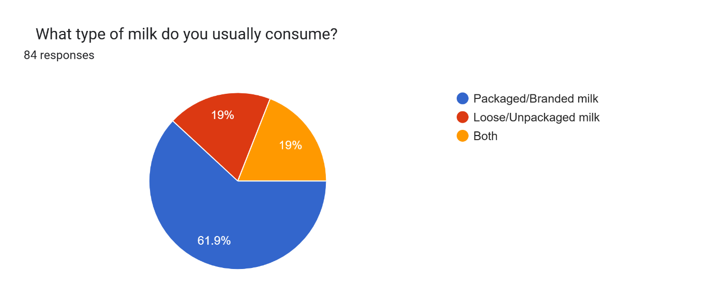
Responses:
- Packaged /Branded milk ~ 61%
- Loose/Unpackaged milk ~ 19%
- Both ~ 19%
2. Factors Influencing Choice of Milk
Question:
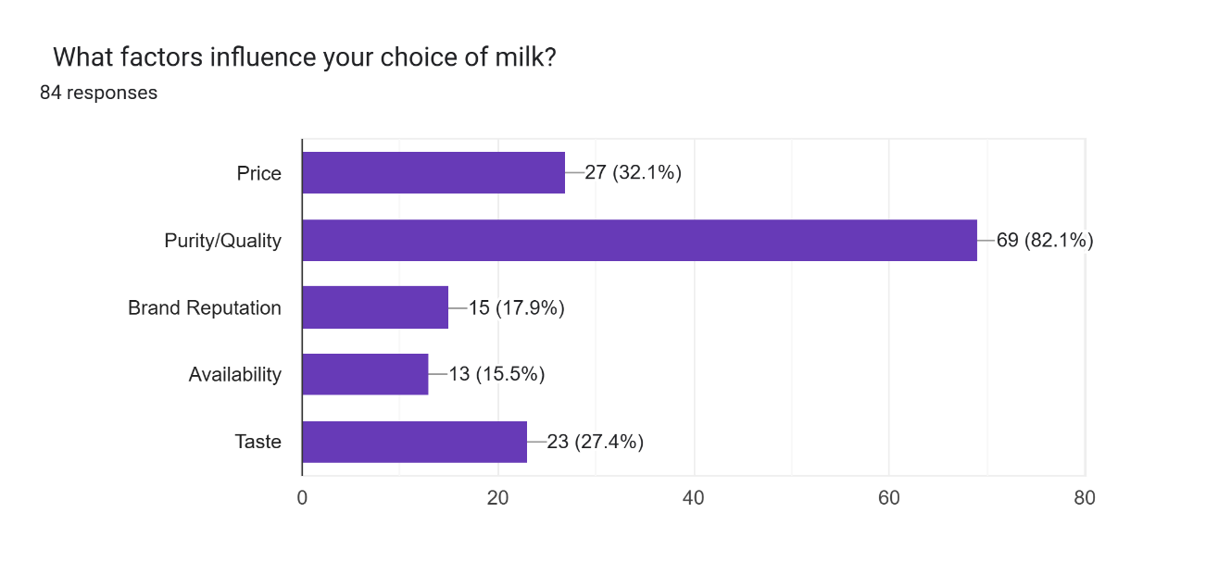
Responses:
- Price ~ 27(32.10%)
- Purity/ Quality ~ 69(82.10%)
- Brand reputation ~ 15(17.90%)
- Availability ~ 13(15.50%)
- Taste ~ 23(27.40%)
3. Checking Labels and Certifications
Question:
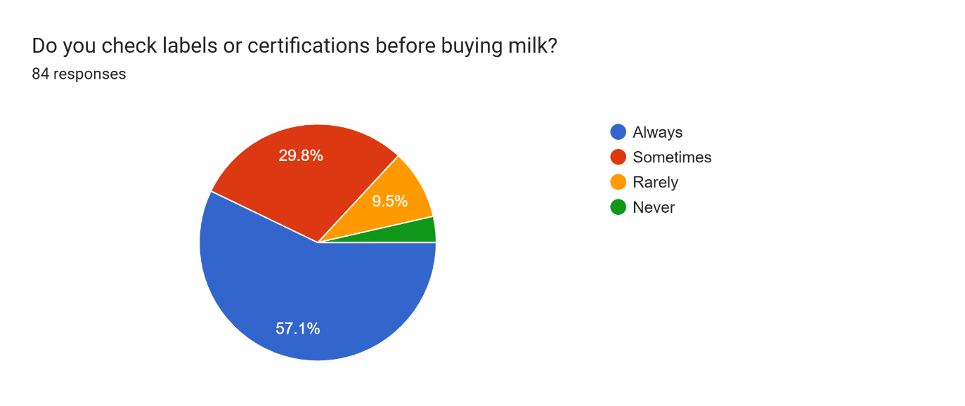
Responses:
  - Always ~ 48(57.1%)
  - Sometimes ~ 25(29.8%)
  - Rarely ~8(9.5%)
  - Never ~ 3(3%)

4. Primary Concern While Purchasing Milk
Question:

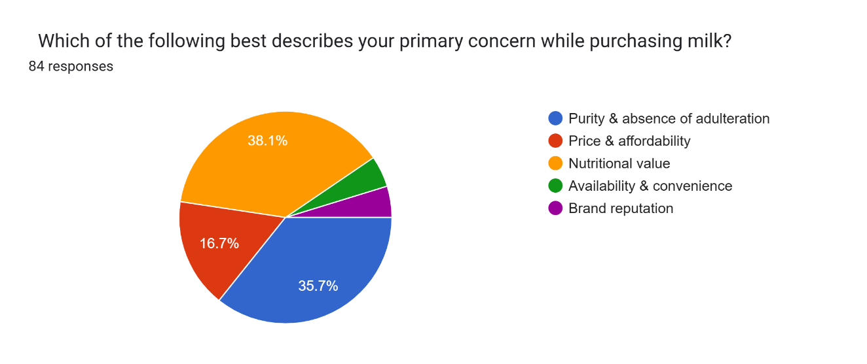
Responses:
  - Purity & absence of adulteration ~ 35.7%
  - Prices & affordability ~16.7%
  - Nutritional value ~38.1%
  - Availability & convenience ~ 4.80%
  - Brand reputation ~ 4.80%

    - Preferred Price Range (Among Willing Respondents)
Question:

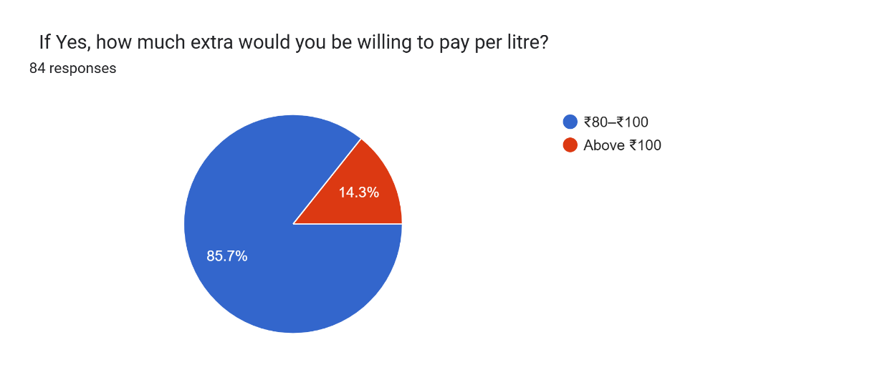
Responses:
- 80-100 ~ 85.7%
- Above 100 ~ 14.3%

    - pay extra for guaranteed pure milk
Question :
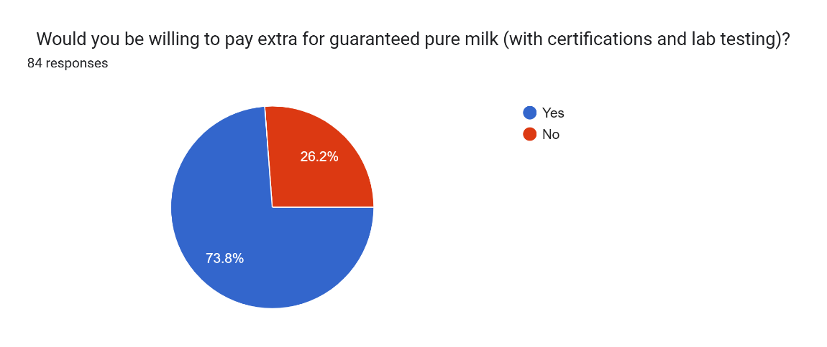
Responses:
- yes ~ 73.8%
- No ~ 26.2%

Interpretation of Results
- Type of Milk Consumed
  - Majority (61.9%) of respondents consume packaged milk, while only 19% still rely on loose milk.
  - Interpretation: This indicates a consumer shift towards branded and trusted sources. CleanMilk can position itself strongly in this packaged milk segment while also converting loose milk users by emphasizing purity and safety.

- Factors Influencing Milk Choice
  - The most important factor is purity/quality (82.1%), followed by price (32.1%), taste (27.4%), brand reputation (17.9%), and availability (15.5%).
  - Interpretation: Consumers are highly purity-conscious and are not primarily driven by price or brand reputation. CleanMilk’s focus on purity assurance directly matches this demand, giving it a strong competitive edge.

- Checking Labels/Certifications
  - More than half (57.1%) of respondents always check certifications, and 29.8% do so sometimes. Very few ignore labels.
  - Interpretation: This shows consumers are actively engaged in verifying quality claims. Providing transparent certifications, QR codes, and lab reports will strongly improve trust in CleanMilk.

- Primary Concern While Buying Milk
  - Top concerns are purity & absence of adulteration (38.1%) and nutritional value (35.7%). Price was less important (16.7%), and availability/brand reputation were very minor concerns (4.8% each).
  - Interpretation: Consumers link milk primarily to health and safety. CleanMilk should therefore brand itself as a health- and purity-driven company, not as a low-cost alternative.

- Willingness to Pay Extra for Pure Milk
  - A strong majority (73.8%) are willing to pay extra for purity assurance, while only 26.2% are not.
  - Interpretation: This finding shows high willingness-to-pay among consumers for guaranteed purity. CleanMilk has the opportunity to adopt a premium pricing model without losing customer interest.

Community Impact
- Improved Public Health
  - By supplying pure, lab-tested milk, CleanMilk reduces risks of adulteration-related illnesses (such as food poisoning, kidney damage, and digestive issues).
  - Healthier milk consumption improves nutrition levels, especially for children and elderly people, who are most vulnerable.
- Consumer Awareness and Education
  - CleanMilk’s transparency tools (labels, QR codes, certifications) encourage consumers to become more conscious about food quality.
  - This contributes to a culture of accountability in the food industry.
- Trust in Local Food Systems
  - By ensuring quality and safety, CleanMilk helps restore trust between farmers, suppliers, and consumers.
  - This reduces dependence on unregulated, loose milk markets.
- Economic Benefits for Farmers
  - CleanMilk can work directly with local dairy farmers, ensuring fair prices and discouraging malpractices (like milk dilution).
  - Farmers who follow purity and safety standards are rewarded, encouraging sustainable dairy practices.
- Reduction in Adulteration Practices
  - The startup sets an example in the dairy industry, creating pressure on competitors to adopt stricter quality control.
  - Over time, this reduces adulteration across the market, benefiting the whole community.

- Employment Generation
  - As the startup grows, it creates jobs in milk collection, testing, logistics, quality control, and distribution, thus contributing to local employment.
- Environmental Responsibility (Long-term Impact)
  - By promoting packaged milk with quality standards, CleanMilk can encourage the use of sustainable packaging and reduce wastage through better supply chain management.

Findings
- Preference for Packaged Milk
  - A majority of respondents (61.9%) prefer packaged/branded milk, while only 19% still depend on loose milk.
  - This indicates a consumer shift towards trusted and safer options.
- Purity as the Top Priority
  - 82.1% of respondents consider purity/quality as the most important factor while purchasing milk.
  - Price, taste, and brand reputation are less influential.
  - This confirms that purity outweighs affordability in consumer decision-making.
- Active Consumer Awareness
  - More than half of the respondents (57.1%) always check labels or certifications, and another 29.8% do so sometimes.
  - This shows that consumers are becoming more cautious and quality-conscious.
- Primary Concerns While Buying Milk
  - The leading concerns are purity and absence of adulteration (38.1%) and nutritional value (35.7%).
  - Price and brand reputation were relatively minor concerns.
  - This indicates that consumers associate milk primarily with health and safety.
- Willingness to Pay Extra
  - A strong majority (73.8%) of respondents are willing to pay extra for guaranteed pure milk, while only 26.2% are not.
  - This opens up opportunities for premium pricing strategies for startups like CleanMilk.
- Potential for Market Differentiation
  - Since purity is both a top concern and a purchase driver, CleanMilk can differentiate itself in the dairy sector by positioning as a purity-first, trust-driven brand.

Website:
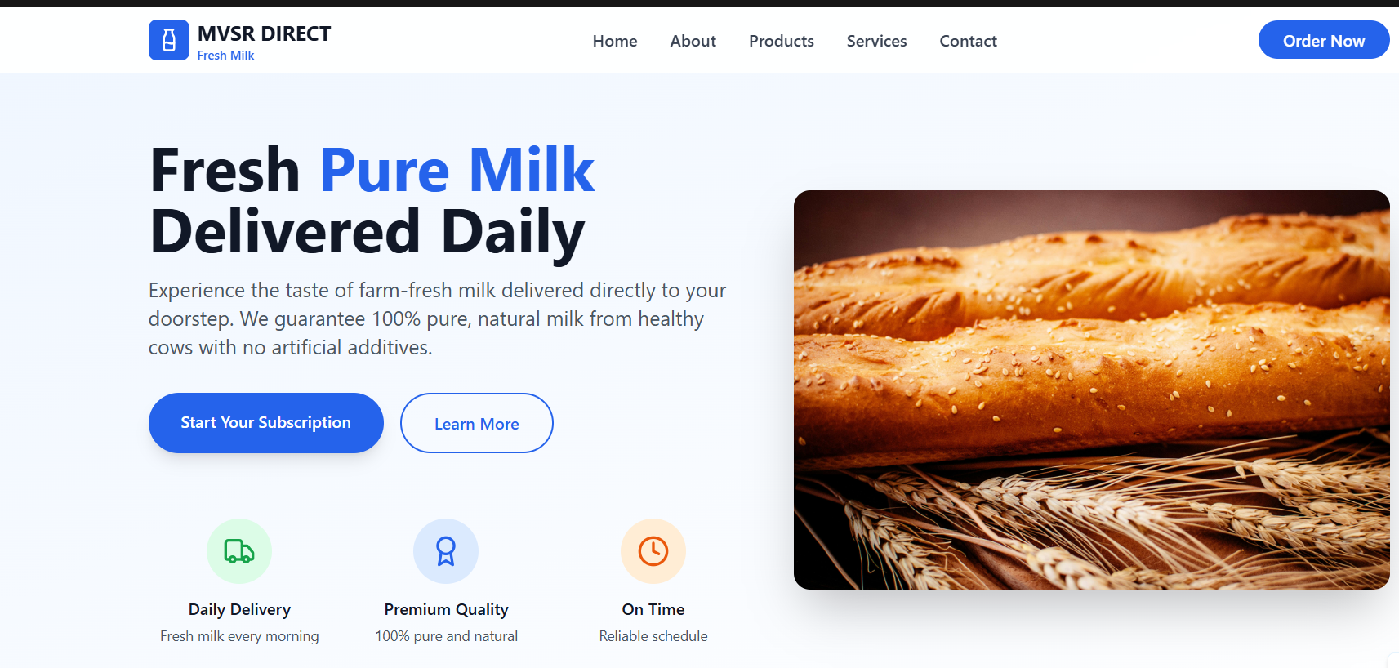
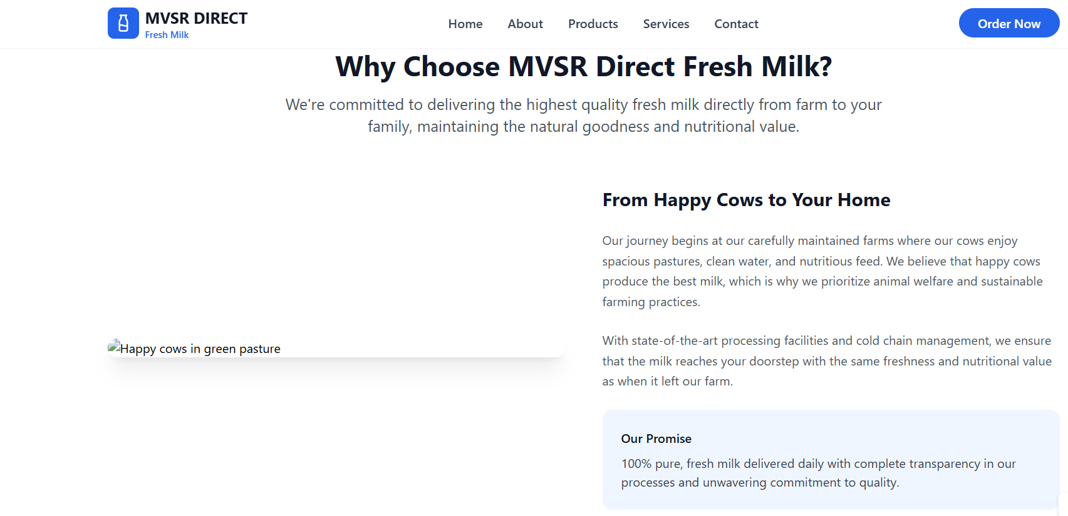

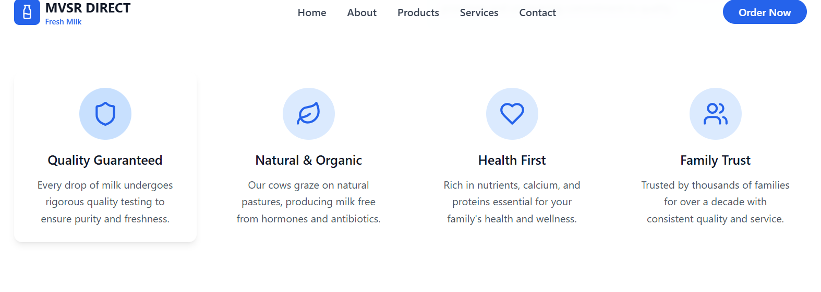
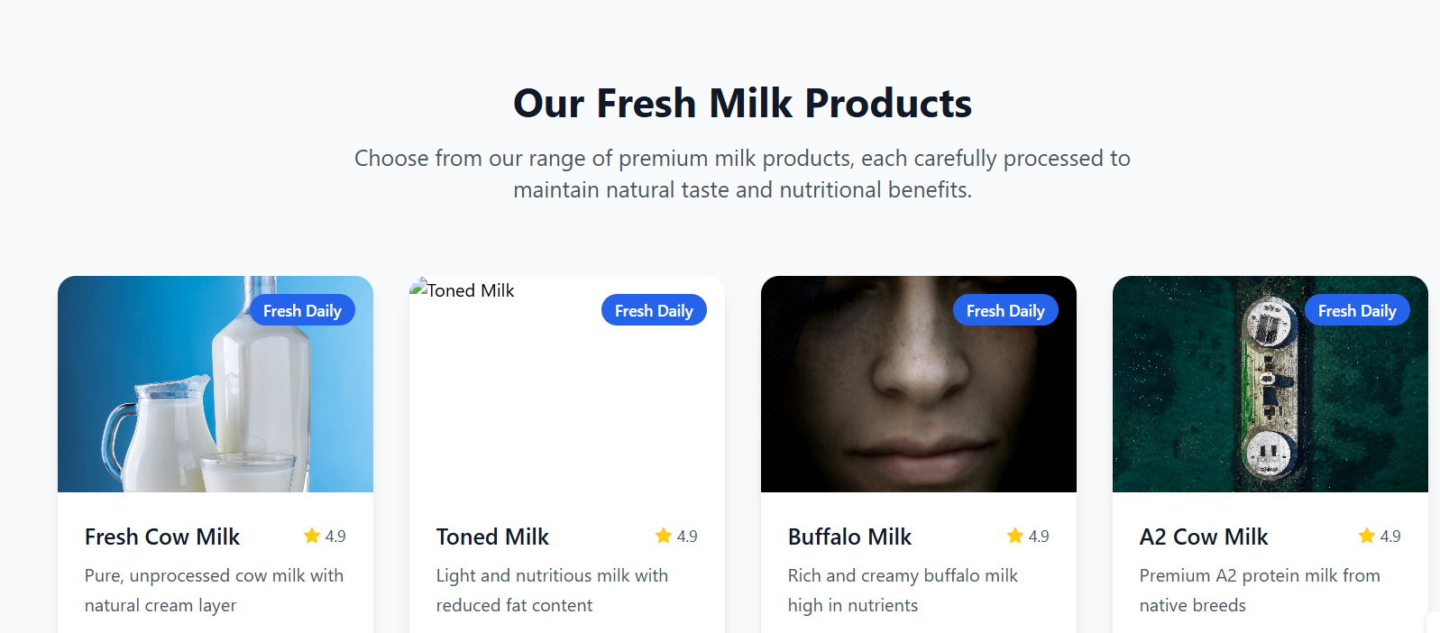

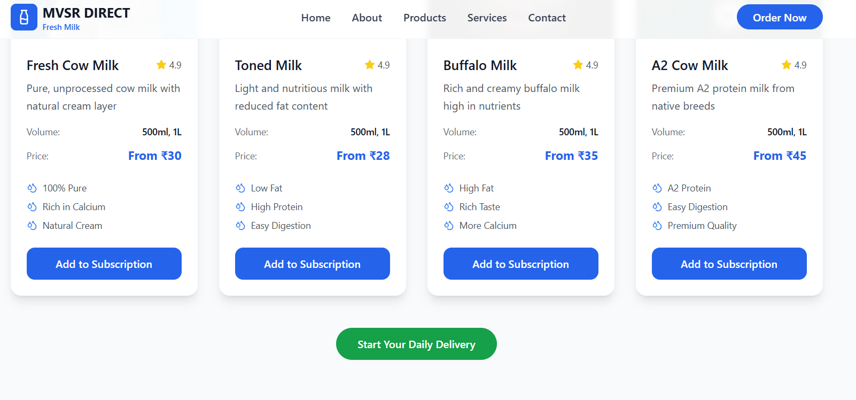
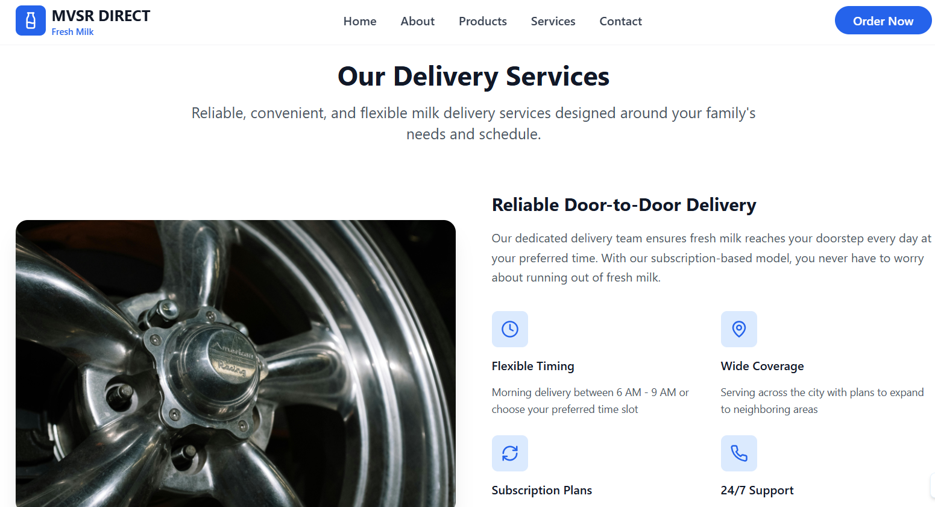
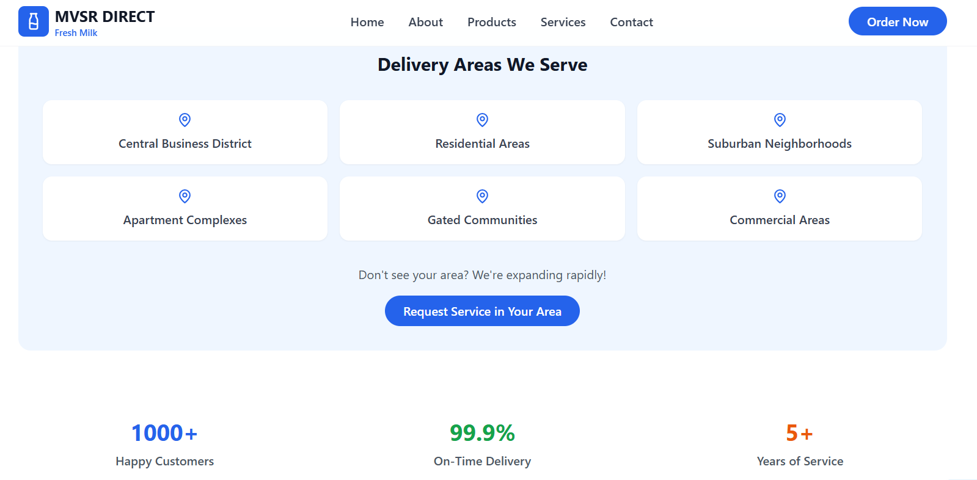
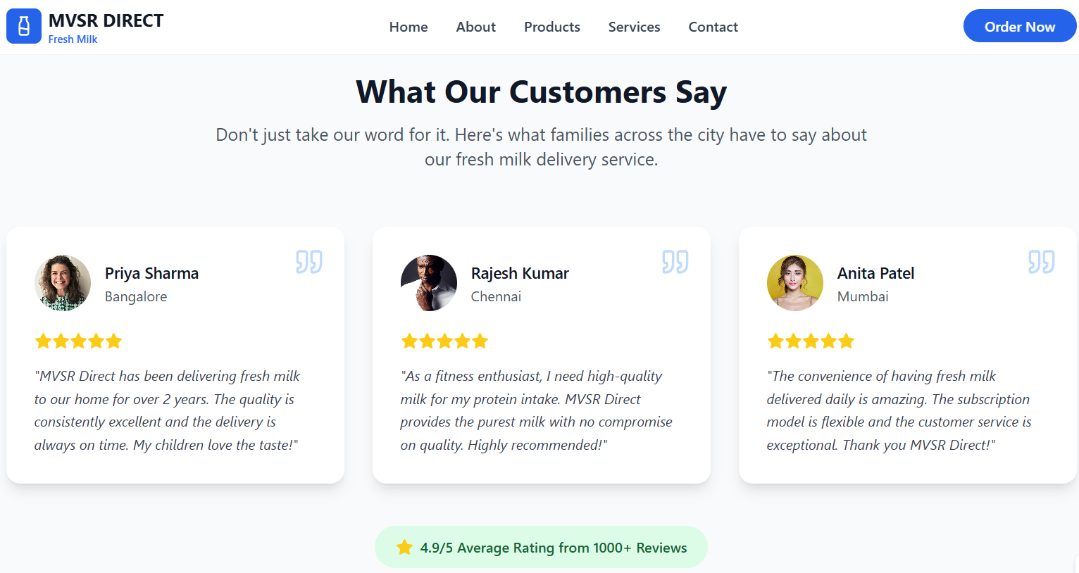
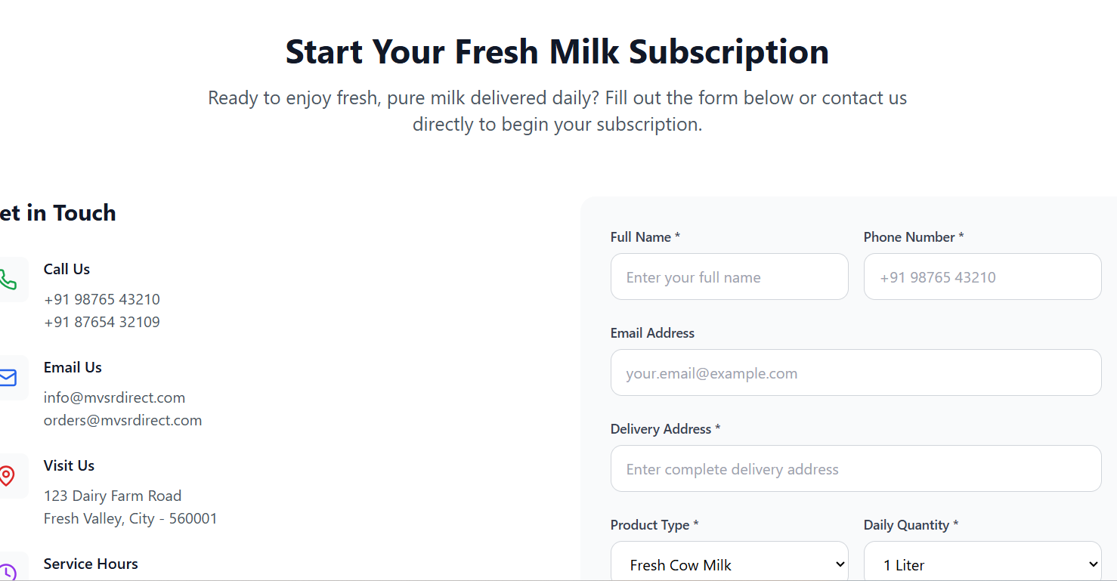
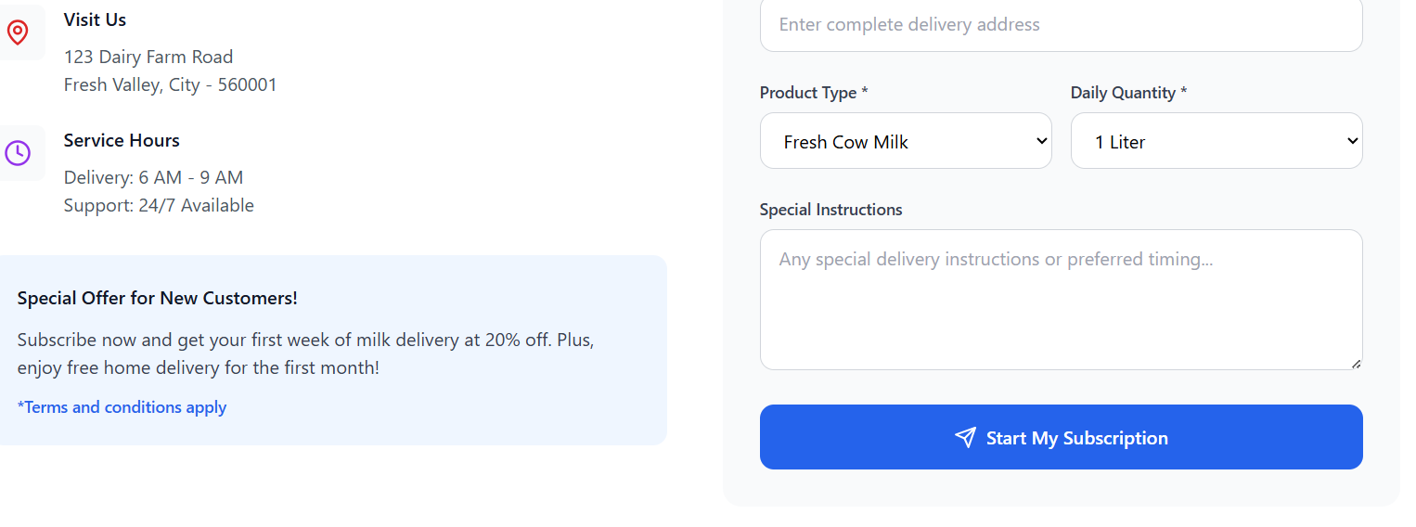
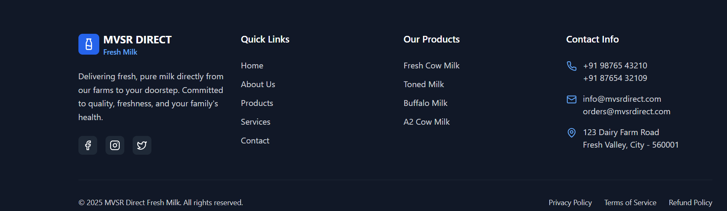

5.Overall Conclusion
Milk purity is a real and common problem, and CleanMilk offers a useful solution to this issue. People trust packaged milk more than loose milk, but many still doubt the value of certifications. Consumers also prefer that purity is kept affordable and not treated as a costly premium. To stand out, CleanMilk should focus on digital tracking, creating awareness, and making the supply chain more transparent. By using simple, low-cost models along with technology, CleanMilk can build strong consumer trust and expand its reach to different regions, similar to successful examples seen worldwide.

